Which of the Following is NOT a correct statement regarding the adoption of a cloud computing model?

-Increases the need for infrastructure management expertise and service provider resources.

Which of the following is the key characteristic of cloud computing?

-All of these.

Which of the following is NOT one of the six factors of the acronym PESTLE?

-Technical

Which service dimension is focused on workflow management systems?

-Information and technology

A method that involves the use of a specially established integrator to ensure the proper coordination of service relationships is known as ________.

-SIAM

According to the organizations and people dimension, when dealing with customers, staffing and training employees, and interfacing with suppliers and partners, attention should be paid to:

-required skills and competencies of individuals/teams.

-leadership styles needed to lead and motivate staff.

-communication and collaboration skills.

Which service dimension is focused on inventory systems?

-Information and technology

Which of the following dimensions is concerned with how an organization’s various parts work in an integrated and coordinated way to enable value creation via products and services?

-Value streams and processes

Which of the following is NOT one of the four dimensions of service management?

-Management and leadership

The ______ dimension of service management includes the elements such as formal organizational structure, roles and responsibilities, all of which are related to the creation, delivery, and ongoing improvement of service.

-Organizations and people

The _______ dimension encompasses an organization’s relationships with other organizations involved in the design, development, deployment, delivery, support, and continual improvement of services.

-Partners and suppliers

A set of interrelated or interacting activities that transform inputs into outputs is known as what?

-Process

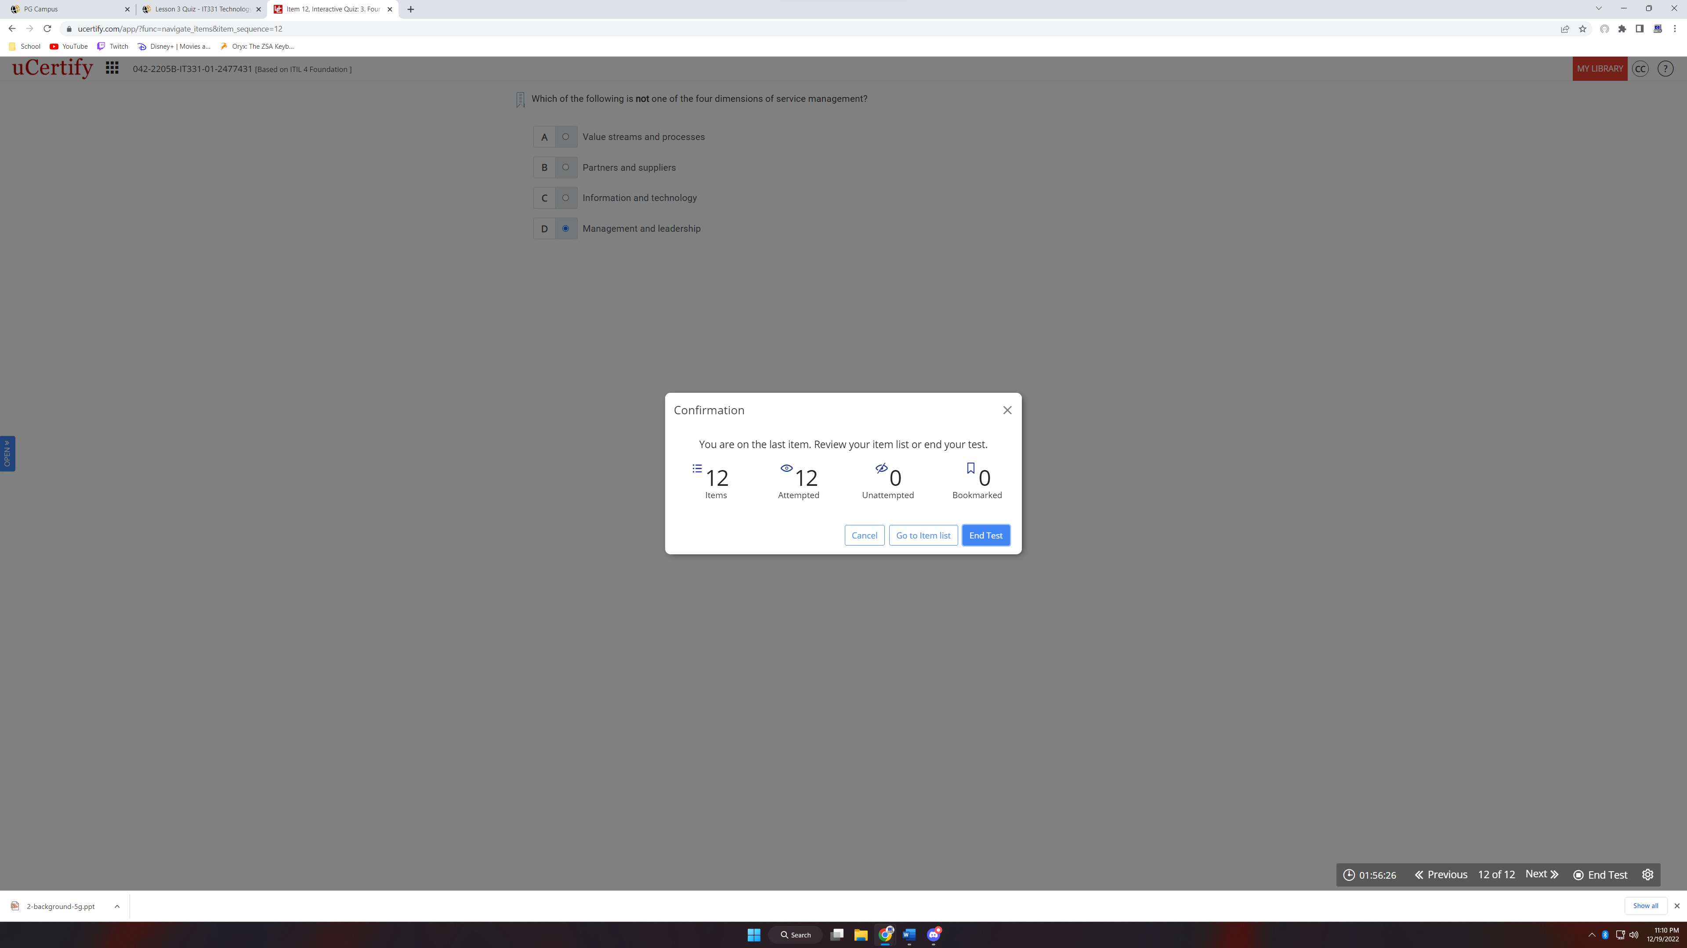

**Part 2: Data Transmission**

1. The 4B/5B encoding schema is used for communications transmissions. Essentially, it aims to optimize transmissions by adding a fifth bit to a symbol that is sent as well as not simply store data in plain bits for easy interception. 4B/5B encoding is composed of the 4-bit desired data which gets translated into a 5-bit symbol that is sent during transmission (Dordal, n.d.). This gives the capacity for all logical 4-bit binary combinations as well as an extra set for IDLE, HALT, START, END, RESET, and DEAD. Manchester Encoding is a technique of using charge states to represent bits. The interaction of the charge state in between time intervals determines the bit value. A low charge to high charge represents a bit value of 1. A high charge to a low charge represents a bit value of 0. This encoding schema is used by high-profile communications methods such as ethernet (Krings, n.d.).

2.

|  |  |  |  |
| --- | --- | --- | --- |
| Type of Media | Maximum Transmission Speed | Distances | Typical Installation Use Cases |
| CAT1 Twisted Pair | 9600bps | N/A | Landline Telephone |
| CAT5 Twisted Pair | 100Mbps | 100 meters | Standard At-Home internet between modem and router |
| CAT7 Twisted Pair | 10Gbps | 100 meters | Server Connections/Gigabit requirements |
| Coaxial Cable | 10Mbps | 500 meters | Local Area Network Backend |
| Fiber-Optic | 10Gbps | 100 kilometers | Server communications, ISP framework |
| Microwave | 1Gbps | 80 Kilometers | Local radio |
| Satellite | 500 Mbps (depending on service provider) | 20,000 Kilometers | Remote internet access. |

3.

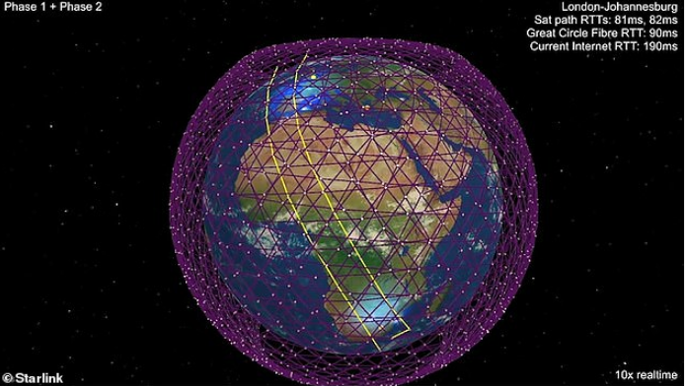

Figure 1. (Liberatore, 2019). Low-Earth Orbit Satellite Coverage.

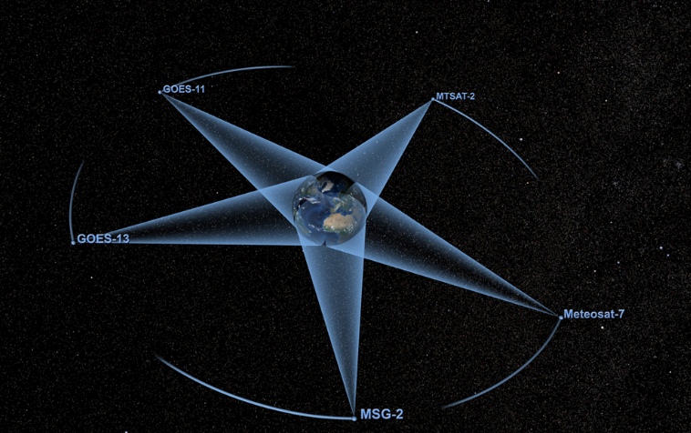

Figure 2. (Howell, 2015). Geosynchronous Orbit Earth Coverage.

In many spots of the globe today, it may not be feasible to have things like an ethernet running to a user’s computer, or a twisted pair cable running to their phone. If they live far outside of cities, and well away from any transmission towers, they may be outside the applicable area of most ISP’s. For these cases, satellite connections may still help to connect them to the outside world. Geosynchronous and low-earth orbit satellites have a number of differences that cement their use-cases for different situations. Although you would typically need fewer satellites to cover the surface of Earth in connections with Geosynchronous satellites, it is substantially more costly per unit. Geosynchronous orbit satellites usually cost up to $30,000 USD per kilogram they weigh whereas low-earth orbit satellites may cost a fraction of that at roughly $5,000 USD per kilogram (Roberts, 2022).

4. USB devices have a number of usability features that make them a practical standard for communications. To start, a USB’s interface is highly standardized. Based on which standard a user chooses, devices with that port will be able to access the files on that drive. Typically, USB-B, there are many USB standards to help devices transfer data in a practical manner. Some benefits to USB devices include a number of important aspects to consider. For example, portability is a strength for USB. Being compact, a USB drive is typically no larger than a simple pack of gum, and have capacities even over a terabyte large. A second benefit to a USB drive is that it is extremely personal. There is very little opportunity for an outside actor to hijack your data, since they would need to be there in person, and plug that specific USB drive into their own machine. This does not come without disadvantages, however. Primarily, a single USB drive is extremely susceptible to data loss. Given their small form factor, USB devices may get lost rather easily depending on the user’s care. Since there is no backup storage should the data’s host computer be inaccessible, it is entirely possible that data may now be gone. Another downside would be the physical presence requirement of a USB drive. One is unable to transfer a USB drive wirelessly since it is hardware itself. Because of this, in order to use a USB drive to transfer data to another computer, a user must accompany the drive to the destination to manually copy the files over. Due to this, automation may be unlikely for this format. With this in mind, a more portable format for data transmission may be cloud storage. With something as simple as a google drive, a user can easily download files hosted instantaneously as long as they have an internet connection. Also, since these files are uploaded to a remote server there will be no loss of data should the host machine or the destination machine be compromised.

# **References**

Dordal, P. L. (n.d.). *4: Links*. Retrieved from Loyola University Chicago--Introduction to Computer Networks: http://intronetworks.cs.luc.edu/1/html/links.html#b-5b

Howell, E. (2015, April 25). *What is Geosynchronous Orbit?* Retrieved from Space.com: https://www.space.com/29222-geosynchronous-orbit.html

Krings, A. (n.d.). *Chapter 5: Signal Encoding Techniques*. Retrieved from University of Idaho: http://www2.cs.uidaho.edu/~krings/CptS-555/Notes-F13/420-13-05.pdf

Liberatore, S. (2019, November 27). *French rival of SpaceX calls out Elon Musk for 'colonizing' low-orbit with 40,000 satellites and warns US firm is turning space into 'Wild West'*. Retrieved from Daily Mail: https://www.dailymail.co.uk/sciencetech/article-7732445/CEO-Arianespace-calls-Elon-Musk-colonizing-low-orbit-40-000-Starlink-satellites.html

Roberts, T. G. (2022, September 1). *Space Launch to Low Earth Orbit: How Much Does It Cost?* Retrieved from Aerospace.csis.org: https://aerospace.csis.org/data/space-launch-to-low-earth-orbit-how-much-does-it-cost/